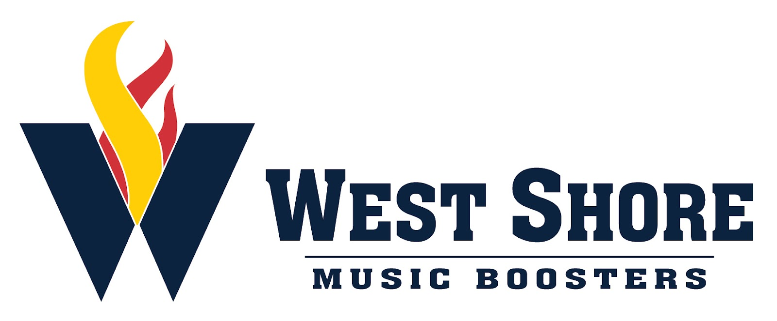

October 6, 2022

General Booster Meeting

Executive Members Present: Sandee Broersma, Jenn Dillman, Deb Lettich, Sheldon Rosenberger, Ben Rupp, Hope Rupp

General Members Present: Thomas Beaman, Debbie Haar, Julie Harman, Kim Housley, Susan McCurdy, Christy Musselman, Michelle Norris, Kristy Rosenberger.

- The minutes of the September 1st meeting were reviewed. A motion to approve the minutes was made by Christy Musselman and seconded by Deb Lettich. The minutes were approved by general consent.

- The budget was reviewed and approved.

- Fundraising
  - Chicken BBQ: event held September 10th went well. Notes for next time: pack spoons, get help for packing meals earlier, decide whether to hold the event on the same day as our Senior Day.
  - R&K: $586 profit for both boosters and student accounts
  - Sponsorship Calendar: collect sponsors for each day in October; due October 24th. Students keep 70% of what they bring in; bonus 10% if they fill up the calendar.
  - Butter Braids/Freckled Moose: Starts Oct. 18, due Oct. 28; delivery Nov. 9

- Save the Dates:
  - Oct. 19 - Cedar Cliff concert
  - Oct. 25 - Red Land Pops Concert
    - Candy grams will be sold at both concerts

- Disney
  - Next payment is due Nov. 4th; $300

- Home Show Review
  - The event went well despite being moved indoors due to rain; over 200 people paid to watch; grams and concessions did well

- Marching Band
  - Trunk or Treat - Oct. 13
  - New Cumberland Halloween Parade - Oct. 18; food table set up at Kelly Financial; need baked goods and candy donations
  - Home Show #2 (Regionals) - October 29; long day with prelims and finals; Swingin’ Sweets and Williams Fries will be there in addition to our concessions; watch for Time to Sign Up lists going out
  - Banquet - Nov. 13 @ LCBC in Mechanicsburg
    - Doors open at 4 pm
    - Eat 4:30 - 5:30; Mission BBQ is catering
    - AUditorium for program and season video
    - 2 tickets per family to start because space is limited
  - Nationals
    - Parent bus may not be available

- Spirit Wear
  - Ordered show shirts will be in tomorrow (10/7) other order is almost ready
  - We will reopen a spirit wear store for holidays sales in mid November

