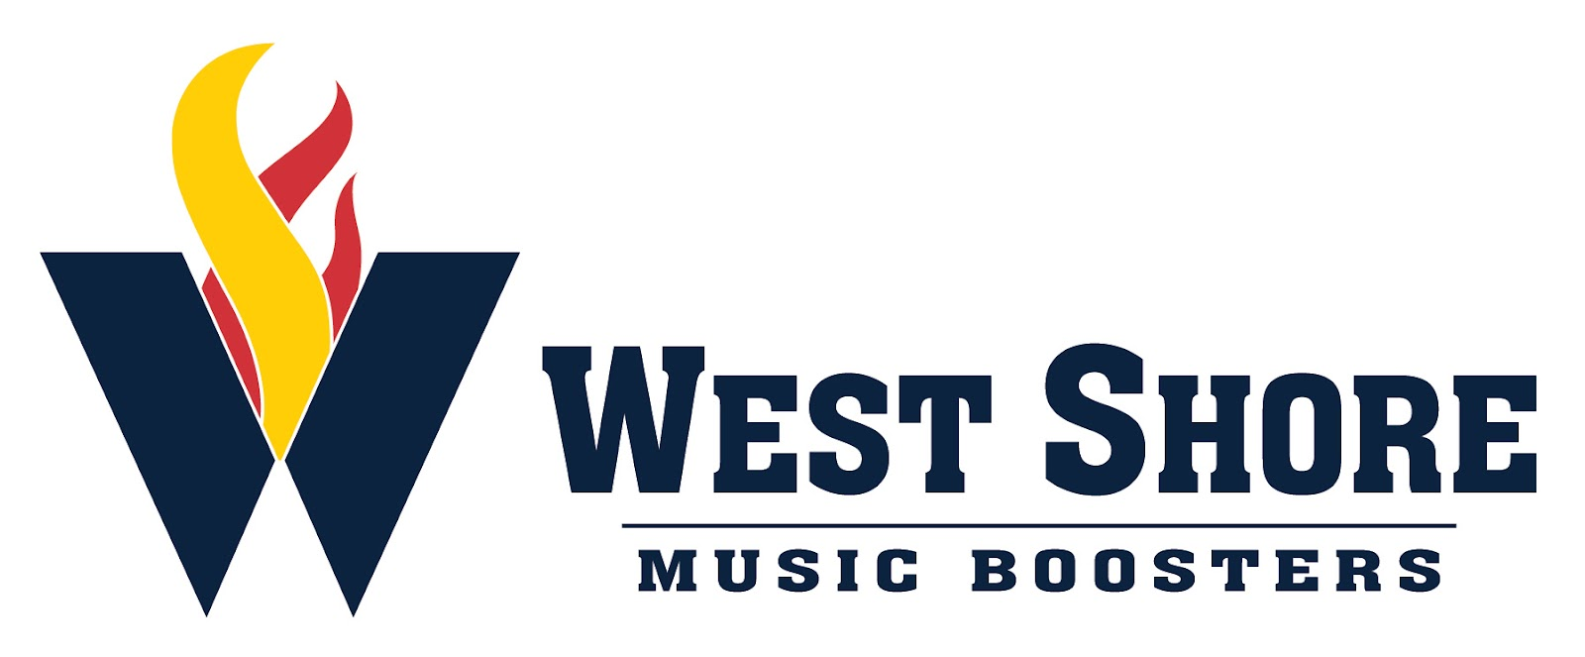

General Meeting Minutes
September 1, 2022

Executive Members Present: Sandee Broersma, Jenn Dillman, Deb Lettich, Sheldon Rosenberger, Ben Rupp, Hope Rupp, Susan Sengoz, April Stevens

General Members Present: Thomas Beaman, Debbie Hoak, Diana Hoffman, Amy Kerstetter, Cindy Kovacevic, Megan Leeds, Sue McCurdy, Deb Smith, Nancy Stout, Michelle Victor

- The minutes of the August General Booster meeting were read. A motion to approve the minutes was made by Nancy Stout and was seconded by Susan Sengoz. The minutes were approved by general consent.
- The 2022 Budget has been approved.
- Fundraising updates:
  - The car wash on August 27th made a profit of $2300!
  - Little Caesar’s sale made a $606 profit (to be split between Boosters and student accounts). Delivery is the week of September 19th.
  - Chicken BBQ: presale orders are due by 9/2.
    - Meal Pick Up is September 10th after the Senior Night Celebration
  - Meat Sticks: $530 profit to be split 50/50 between Boosters and student accounts. 5 cases have been ordered so far.
  - Next up: R & K and Duth Mill Bulbs; Sponsor calendar will be set up for October
- Disney
  - The next payment is due 9/9. ($300)
- Spirit Wear Close Dates: 9/9 (main store) and 9/11 (marching band show shirts)
- Marching Band
  - Senior Nights
    - Marching band students will walk out as a group when the schools celebrate their senior football players and cheerleaders
    - Marching Band Senior Night - September 10th @ 4:30 pm
      - Seniors will walk with parents while their bios are read.
      - Uniformed performance of the show
      - Dunk-a-Director (car wash winner reward)
      - Desserts available after celebration on the field

  - Trunk or Treat: Thursday, October 13
    - Set up cars 7:30 pm - 8: 30 pm and students will trick-or-treat at the end of practice
  - Stadium Clean up
    - September 9, 15, 23, 30 and October 28
  - Home Show Meeting: September 22
  - Pit Pushing Help needed
  - Football help needed: filling water and putting on seat covers
  - Marching Band Banquet: November 13

